DEPLOYMENT GUIDE OF GLYCE & LIFE

1) How to deploy the application GLYCE & LIFE:

You can launch the application by running the executable JAR file from the command line:
a) download the latest release of the executable JAR file (springGlyce-0.0.1-SNAPSHOT.jar) from GITHUB:
https://github.com/vagaste/sprinGlyce/releases

b) from the command line, in the folder of the executable JAR file, type:

java -Dfile.encoding=UTF-8 -jar springGlyce-0.0.1-SNAPSHOT.jar

(the command dfile.encoding allows to keep special caracters of the file used by the database H2).

c) In the web browser, type : http://localhost:8090

2) How to refresh the executable jar file:

If modifications are made on the code of the front end AngGlyce and back end SprinGlyce, the executable jar file must be made again.
To integrate the front part with the back:

The front is developped with angular 6. To integrate it with the back end, type in the command line on the folder project AngGlyce:

NG BUILD --PROD

A folder « dist » is created.
Copy contents of the folder « anglyce » that is inside the folder « dist », and paste it in a new folder « static » in the project SprinGlyce, as following:

sprinGlyce\src\main\resources\static
Make an update maven project of the project SprinGlyce in eclipse.

To create a new executable jar file:
On the pom.xml of SprinGlyce:

- « run as clean » to delete the existing executable jar,
- « run as install » to create a new executable jar (snapshot.jar) in the folder target.

To create a new release in GitHub:

Zip the snapshot.jar to make a new release in gitHub.
In GitHub, draft a new release : https://github.com/vagaste/sprinGlyce/releases
Follows the instructions, select the zipped snapshot.jar file and publish release:

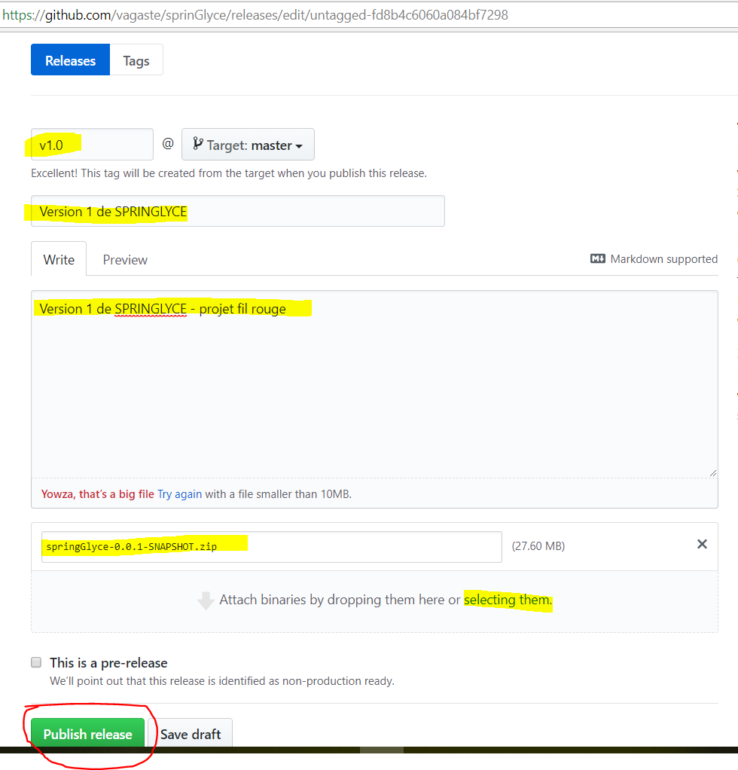

3) Database :

The database (H2) contains 4 tables:

- the table « aliment »: contains the aliments, number of calories, the categorie of the aliment (foreign key on category’s table), etc. This table is automatically filled at lauching of the application with the file « data.sql ».

- the table « category »: repository of the aliment’s category (identifier and name). This table is automatically filled at lauching of the application with the file « data.sql ».

- the table « portions »: contains the portions needed to constitute a recipe with the quantity of aliment, a foreign key on the aliment used et a foreign key on the recipe which contains the portion. This table is updated whith the application GLYCE & LIFE.

- the table « recette » (recipe): contains the name of the recipe and the overall value of glycemic load and nutritional values. This table is updated whith the application GLYCE & LIFE.

